[30 Days of Thanksgiving](https://drive.google.com/folderview?id=0BzEgD9KiYchEWnBqaERUanMzWFk&usp=sharing)/[**Day 1**](https://drive.google.com/folderview?id=0BzEgD9KiYchEOWJCWHZvMHFRdnM&usp=sharing)

# Thankful for Fall Colors

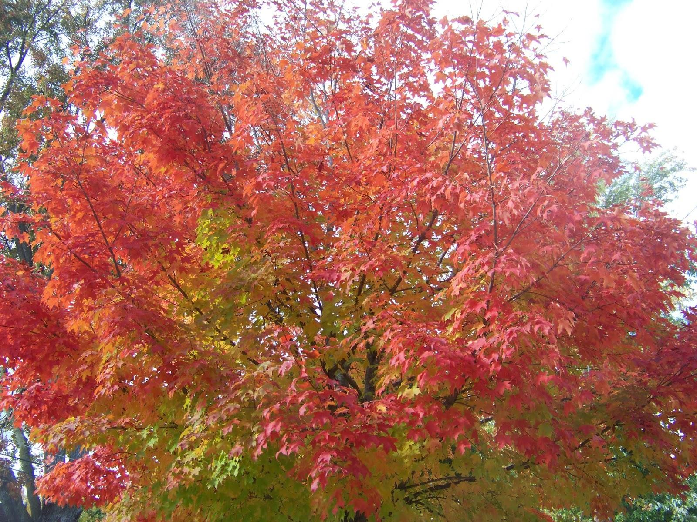

I’ve been really thankful this year for the changing colors on the trees. Back when the weather was warmer, it was really fun to be outside surrounded by so many shades of orange and red. The week when we were moving to our new house, my niece, Allyson, and I were inspired to walk around a little bit to take a picture of the changing colors on the tree. This was a rare opportunity for me to see her at work behind the camera, and it was good to take advantage of our common interest in photography.

There was a tree a few feet from our door which stayed a vibrant red for the longest time. Lately, when I glanced at it I realized that the branches were almost completely bare. It was a little sad that the leaves had fallen off and I wouldn’t have something so pretty to enjoy anymore. But, it is reassuring that the leaves will grow back next year, and we would have the same view again in the Fall.

My mom was talking to me recently about needing to buy a car to replace her van. She told me that she can’t believe she has owned the van for 17 years, but that this didn’t sound like such a long time. I pointed out that in the seventeen years, I’ve graduated college, gotten married, moved five times, worked at six different jobs, and had three kids. Seventeen years ago, my Grandfather was a live and a healthier. My dad still had both legs.

Of course, I am also a different person than I was back then. I want to say that I’ve improved with the help of managers, my wife, and even my kids. But, there’s also room for improvement, so I’d say it’s premature to say anything.

I’m thankful that the Fall colors are a reminder that change is inevitable, but sometimes changes do make us better.

[View Online](https://docs.google.com/document/d/1iDHYwzGd1KMu0PXr0hq-zKuxW__F3U4mj7UE6ZEsCLk/pub) / [Comment on this Article](https://docs.google.com/document/d/1iDHYwzGd1KMu0PXr0hq-zKuxW__F3U4mj7UE6ZEsCLk/edit?usp=sharing) / [Respond](https://plus.google.com/116735725243779317831/posts/YKpAw8KFXn3) / [Propose a new Article](https://cyberland.tenderapp.com/discussions/30dot) / [Send Email](mailto:cyberlandhq@gmail.com)